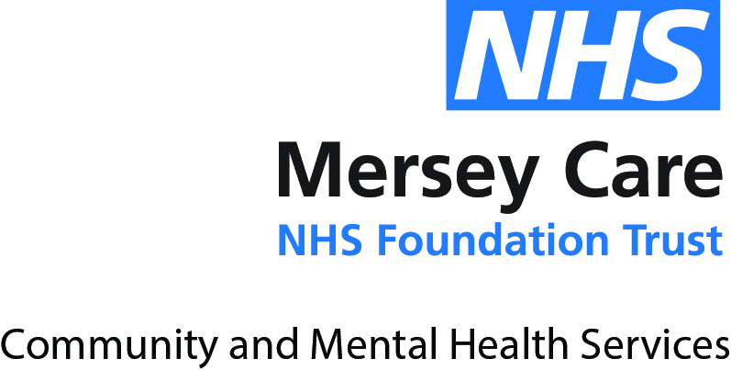

27 April 2021

vanessafillis.journalism@gmail.com

Dear Ms Fillis

**FREEDOM OF INFORMATION REQUEST AND RESPONSE**

**REF: MCT/FOI/2021/5714**

Further to your Freedom of Information request in respect of housing support, please find a response from the Trust below.

Mersey Care NHS Foundation Trust provides adult specialist mental health, addiction, learning disability and community health services.

We provide specialist inpatient and community mental health, learning disabilities, addiction services and acquired brain injury services for the people of Liverpool, South Sefton, and Kirkby, Merseyside.

We serve more than 11 million people providing community physical health services in Liverpool and South Sefton, secure mental health services for the North West of England, the West Midlands and Wales and specialist learning disability services across Lancashire, Greater Manchester, Cheshire and Merseyside.

**1. The number of nurses or support workers who support patients regarding their housing while they are inpatient in a mental health unit. These could be housing officers, housing support workers, special housing nurses, or similar professions that are specialised in housing support.**

Assessing social needs is part of any admission and undertaken via an inpatient multi-disciplinary team approach.

Referrals are made to the Local Authority re housing needs if they meet a criteria of need.

Crisis Resolution and Home Treatment Team (CRHT) and community mental health team (CMHTs) will often support service users at any given time re accommodation.

Mersey Care NHS Foundation Trust has discharge co-ordinators who we can link in with. The Trust can also escalate any housing issues/difficulties for discharge via RADAR/delays. Housing referrals can be made to Crosby Housing and Re-enablement Team (CHART), housing options, JIGSAW, register on property pool etc. The Trust can also refer to Nightingale house and link in with social services etc. The Trust also have CHART workers for Sefton patients that would support with property applications and bids right through to organising tenancies.

Occasionally housing would fall under the remit of the local authority if it was commissioned as part of a package of care in which case support would also be given by a social worker.

**2. The protocol for discharging homeless patients or patients who face homelessness after their discharge. Please provide a document with the discharge policy or, if there is no document, please state what the protocol is.**

The Trust would not discharge anyone to be homeless and at the very least would ensure they were going to a hostel.

**3. The number of nurses or support workers who support mental health patients regarding their housing while they are in the community. These could be housing officers, housing support workers, special housing nurses, or similar professions that are specialised in housing support.**

Community Mental Health Teams do not employ nurses or support workers specific to housing, however our nurses and support workers do support service users to link in with the appropriate housing agencies and providers, CHART, private landlords or Light for Life. The teams would refer to social care if a needs assessment was required.

The Life Rooms supports many service users around housing issues. Whilst the Trust do not employ specific housing advisors our Pathways Advisor Service offers support through social prescriptions to the following partner organisations:-

Shelter

Human Kind

Sefton Housing Options

Light for Life

Crosby Housing and Re-enablement Team (Chart)

Sefton Citizens Advice Bureau

The Trust has 2 x Pathways Advisors and 1x Senior Pathways Advisor. Since October 2018 the Trust has had 259 referrals to support Mersey Care service users with housing needs

If you are unhappy with the way your request for information has been handled, you can request a review by writing to:

Jeanie Hedley,

Head of Information Governance and Data Protection Officer,

Mersey Care NHS Foundation Trust and North West Boroughs Healthcare NHS Foundation Trust

V7, Kings Business Park

Prescot

L34 1PJ

Email: freedomofinformation@merseycare.nhs.uk

If you remain dissatisfied with the handling of your request or complaint, you have a right to appeal to the Information Commissioner at:

The Information Commissioner's Office,

Wycliffe House, Water Lane, Wilmslow,

Cheshire, SK9 5AF.

Telephone: 0303 123 1113 Website: [www.ICO.org.uk](http://www.ICO.org.uk)

There is no charge for making an appeal.

**Please Note**: Under the Privacy and Electronic Communications (EC Directive) Regulations 2003, Mersey Care NHS Foundation Trust asks not to receive unsolicited marketing communications.

Thank you for your interest in Mersey Care NHS Foundation Trust.

Yours sincerely

**FREEDOM OF INFORMATION TEAM**